 CHEMICAL ENGINEERING TRANSACTIONS  VOL. xxx, 2026 | A publication of  
The Italian Association
of Chemical Engineering
Online at www.cetjournal.it

Guest Editors: Flavio Manenti, Botir Usmonov, Alessandro Di Pretoro
Copyright © 2026, AIDIC Servizi S.r.l.
ISBN 979-12-81206-xx-x; ISSN 2283-9216

Investigation and Synthesis of New Heterocyclic Derivatives Based on Benzotriazole and Benzimidazole
Shakhnoza A. Tadjieva^{a*}, Aytura S. Maksumovaª, Gulmira A. Tadjieva^{b}, Saida Abdukarimova^{b}, Nigora S. Matkarimovaª, Guzal R. Khakimovaª
ªTashkent Institute of Chemical Technology, Tashkent, Uzbekistan
^{b}Tashkent State Technical University named after Islam Karimov, Tashkent, Uzbekistan
tshah84@mail.ru

The synthesis and study of nitrogen-containing heterocyclic acrylic monomers are of significant scientific and practical interest. This study reports the synthesis of new acrylic monomers based on benzotriazole, benzimidazole, and acrylic acid. The reactions were carried out in an organic solvent medium under substrate-specific conditions: benzotriazole with acrylic acid at 80 °C for 5 h and benzimidazole with acrylic acid at 60–70 °C for 10 h. The obtained products were white crystalline substances with yields of approximately 80 % for BTAA and 76–78 % for BIAA. The melting points were determined on a Boetius heating stage and were 279 °C for BTAA and 274 °C for BIAA. The synthesized monomer dissolves well in organic solvents (ethanol, acetone, dimethylformamide, and dimethyl sulfoxide.). Purity was confirmed via High-Performance Liquid Chromatography (HPLC). The influence of solvent type, reagent ratio, temperature, and reaction time on the monomer yield was systematically examined. The structure of the synthesized monomers was validated by Infrared (FT-IR) spectroscopy, while their thermal properties were assessed using thermogravimetric (TGA) and differential thermal (DTA) analysis.
  - Introduction
Derivatives of nitrogen-containing heterocyclic compounds are of considerable interest from both theoretical and practical perspectives. The fields of application of these compounds are highly diverse. At present, among benzazoles containing two or three nitrogen atoms in the molecular structure, benzimidazole, benzotriazole, and their derivatives are the most widely used. These compounds are employed as anticorrosive additives, detergents, antifogging agents in photography, antifreeze components, optical brighteners for various materials, and UV absorbers in cosmetic formulations. In addition, benzotriazole and its derivatives have found extensive application as pharmaceutical and therapeutic agents (Khayyat et al., 2021).
Some benzotriazole derivatives bearing various substituents in their molecular structure belong to a broad class of biologically active compounds, exhibiting anticancer, antiviral, antibacterial, antifungal, antioxidant, antihypertensive, and anticoagulant properties (Datta et.al., 2020). Benzotriazole derivatives with long carbon chains act as effective corrosion inhibitors for copper in NaCl media by forming a stable adsorbed protective film on the metal surface, significantly increasing inhibition efficiency (Gong et al., 2015)
Benzotriazole derivatives are considered biologically active compounds with pharmacological potential (Dandge et al., 2023). It has been demonstrated that benzotriazole-6-carboxylic acid acts as an inhibitor of cytosolic phospholipase A2 (CPLA2) and exhibits pronounced anti-inflammatory activity. The anti-inflammatory effect was found to decrease when the carboxyl group within the benzotriazole scaffold was replaced by carboxyindole or carboxybenzimidazole moieties.
The corrosion inhibition efficiency of 5-chlorobenzotriazole was investigated for AA2024-T3/CFRP galvanic couples in a NaCl medium, and the results confirmed the relevance of benzotriazole derivatives as promising inhibitors for engineering corrosion-protection studies (Duque-Alvarez et al., 2017).
The authors synthesized derivatives of benzotriazole and benzimidazole using two different methods, including 1-octyl-1,3-dibutyl-1N-benzotriazole, 1-butyl-3-octyl-1N-benzotriazole, 1,3-dioctyl-1N-benzotriazole, 1,3-dibutyl-1N-benzotriazole, and 1-octyl-1N-benzimidazole. The use of acetonitrile as a solvent resulted in lower yields compared to the DMF/KOH system, which provided higher yields of up to 92%. In particular, quaternary products were not formed in acetonitrile, whereas in the DMF/KOH medium, the reaction proceeded with the formation of quaternary salts (Tajudeen et al., 2022).
In another study, the water-soluble diallyl monomer N,N-diallylbenzotriazolium bromide, containing quaternary nitrogen atoms, was investigated. The synthesis of this monomer was carried out via the reaction of benzotriazole with allyl bromide at 50–60 °C in an organic solvent. Acetone, ethanol, and toluene were employed as the reaction media (Tadjieva et al., 2020; Tadjiyeva and Maksumova, 2020)
Furthermore, other authors synthesized the monomer 2-(bis((1H-benzotriazol-1-yl) methylamino) ethyl acrylate) (BMEA), which contains two lateral benzotriazole groups (Mariano et al., 2023). Upon solution polymerization of this monomer, an adsorbent was obtained, demonstrating a strong affinity for moisture absorption from the air.
The study describes the synthesis of benzotriazole-containing acrylate polymers with varying fluorine content in the alkyl side chain (Han et al., 2023). The authors investigated the thermal and optical properties of the polymers, as well as the surface characteristics of thin films deposited on flexible PET substrates. The fluorinated polymers demonstrated excellent thermal stability, low surface energy (high hydrophobicity), low refractive index, and high visible-light transmittance, in addition to ideal ultraviolet (UV) blocking properties.
In another study, a series of benzotriazole derivatives were synthesized using both microwave-assisted irradiation and conventional heating methods for comparison (Shah and Krishnapriya, 2014). All synthesized compounds were characterized by melting point determination, differential scanning calorimetry (DSC), infrared (IR) spectroscopy, and ^1H NMR spectroscopy. The conventional and microwave-assisted syntheses were compared in terms of overall reaction time and yield. Results indicated that microwave synthesis led to higher yields within significantly shorter reaction times. The authors also analyzed the influence of the structure of several benzotriazole derivatives containing phenolic, benzyl, and benzyloxybenzyl groups on their biological activity. Toxicity and cytogenetic activity were studied for six benzotriazole derivatives, including 4-(1H-benzotriazolylmethyl) phenol, 1-benzyl-benzotriazole, 1-[4-(benzyloxy)benzyl]-1H-benzotriazole, and 1-[2-(benzyloxy) benzyl] -1H-benzotriazole, using Allium fistulosum assays. It was shown that compounds containing para-positioned OH and benzyl groups exhibited higher toxicity. Depending on the molecular structure, the compounds inhibited proliferative activity at different mitotic stages. Data also demonstrated the relationship between molecular structure and biological properties of the synthesized derivatives (Selezneva et al., 2012).
Given the above, the synthesis and study of nitrogen-containing heterocyclic compounds are of significant scientific and practical interest. Based on these considerations, the objective of the present study is the synthesis of novel monomers based on benzimidazole and benzotriazole with acrylic acid and the investigation of their corrosion inhibition properties. In this study, a new functional monomer was synthesized through the introduction of an acrylic fragment into the benzotriazole molecule, which simultaneously exhibits the properties of both a corrosion inhibitor and a polymerizable functional monomer. This monomer can be included in the polymer chain due to the acrylic group, while maintaining the high adsorption capacity of benzotriazole relative to the metal. This leads to a strong adhesion of the inhibitor to the composition of the polymer coatings and an increase in the effectiveness of corrosion protection.
  - Methodology
Benzimidazole, benzotriazole and acrylic acid were used as the main starting materials. Before synthesis, the reagents were purified according to appropriate laboratory procedures described in the literature (Kuksenok and Shtrykova, 2023).
    - Synthesis of 1H-Benzotriazole Acrylic Acid (BTAA)
BTAA was synthesized in an organic solvent medium at 80 °C for 5 h. The reaction was carried out in a glass reactor equipped with a reflux condenser and a magnetic stirrer. Benzotriazole (1 mol) was first dissolved in dimethylformamide (10 mL), and the resulting solution was stirred at room temperature for 5 min. Subsequently, acrylic acid (1 mol) containing 0.1 g of hydroquinone as a polymerization inhibitor was added dropwise to the solution. After the addition of acrylic acid, EDC (1.0 mol relative to acrylic acid) was added portionwise to the reaction mixture under continuous stirring in order to activate the carboxyl group of acrylic acid. The mixture was stirred at room temperature for 20–30 min and then heated to 80 °C. The reaction mixture was maintained at 80 °C under constant stirring for 5 h. After completion of the reaction, the mixture was cooled to room temperature, leading to the formation of light-yellow crystals. The precipitate was separated by vacuum filtration and washed with distilled water. The obtained product was isolated as a white crystalline substance with a yield of approximately 80 %.
    - Synthesis of 1H-Benzimidazole Acrylic Acid (BIAA)
Benzimidazole (1 mol) was initially dissolved in dimethylformamide (10 mL), and the resulting reaction mixture was stirred at room temperature for 5 minutes until a homogeneous solution was obtained. Subsequently, acrylic acid (1 mol) was added dropwise to the system, and the reaction mixture was maintained at 60–70 °C under constant stirring for 10 hours. After complete addition of acrylic acid, EDC (1.0 mol relative to acrylic acid) was added portionwise under continuous stirring to activate the carboxyl groups of acrylic acid. Upon completion of the reaction, the mixture was further left at room temperature for 5 hours, which led to the formation of a crystalline precipitate. The resulting crystals were collected by filtration. The obtained product was a white crystalline substance with a yield of 76–78 %.
Fourier-transform infrared (FT-IR) spectroscopic analysis was performed using a Spectrum Two FT-IR spectrometer (PerkinElmer, USA, 2019) equipped with an attenuated total reflectance (ATR) MIRacle-10 accessory with a diamond/ZnSe prism. Spectra were recorded over the wavenumber range of 4000–400 cm⁻¹ with a spectral resolution of 4 cm⁻¹. The signal-to-noise ratio was 60,000:1, and the scanning speed was 20 spectra per second.
Thermoanalytical studies of the synthesized product were performed using a Simultaneous Thermal Analyzer STA 409 PG (Netzsch, Germany), equipped with a type K thermocouple (LowRGSilver) and aluminum crucibles. All measurements were carried out under an inert nitrogen atmosphere with a gas flow rate of 50 mL/min. The temperature range of the experiment was 25–370 °C, and the sample mass for a single measurement was 5–10 mg. The calibration of the measurement system was performed using a standard set of substances: KNO₃, In, Bi, Sn, and Zn.
The melting points of the synthesized compounds were determined using a Boetius heating stage (Germany). The purity of the obtained products was assessed by thin-layer chromatography (TLC) on Silufol UV-254 plates, using a benzene–methanol mixture (3:1) as the mobile phase.
High-performance liquid chromatography (HPLC) analysis of the synthesized compounds was carried out on an Agilent 1260 Infinity II chromatograph (USA). Chromatographic conditions included the use of a Poroshell 120 EC-C18 column (4 μm, 4.6 ×150 mm) equipped with a diode array detector. The eluent consisted of an acetonitrile–water mixture (50:50) at a flow rate of 1 mL/min. Detection was performed at a wavelength of 246 nm, with an injection volume of 5 mL. The column thermostat temperature was maintained at 30 °C, and the total analysis time was 5 minutes.
NMR spectra were recorded on the Varian UNITY-400 device in CD3OD solutions at 22°C.
  - RESULTS AND DISCUSSION
This section presents the synthesis conditions, reaction observations and physicochemical characteristics of the obtained nitrogen-containing heterocyclic monomers.
    - . Reaction conditions and observations
In the present study, nitrogen-containing heterocyclic derivatives based on benzotriazole and benzimidazole with acrylic acid were synthesized and investigated. The reactions can be represented by the synthetic schemes shown in Eq(1) and Eq(2).
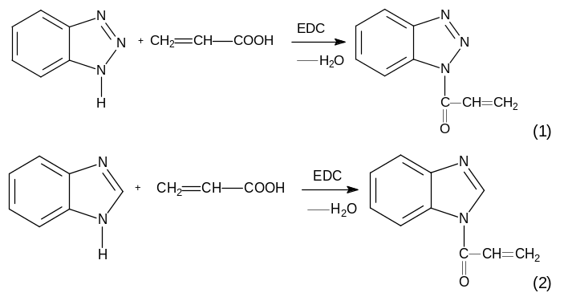
The synthesized monomers exhibited good solubility in selected organic solvents. To determine the optimal synthesis conditions, the effects of temperature, reaction time and the molar ratio of the starting reagents were systematically investigated. For the reaction between benzotriazole and acrylic acid, the optimal conditions were established as a molar ratio of 1:1, a temperature of 80 °C and a reaction time of 5 h. For the reaction between benzimidazole and acrylic acid, the synthesis was carried out at 60–70 °C for 10 h. The physicochemical properties of the synthesized monomers are presented in Table 1.

Table 1: Physical and chemical characteristics of BTAA and BIAA
Compound | Molecular  formula | Physical state | Molar mass,  g mol⁻¹ | Melting  point, °C | Solubility
BTAA | С₉Н₇N₃O | White crystals | 173 | 279 | Ethanol, dimethylformamide, acetone
BIAA | С₁₀Н₈N₂O | White crystals | 172 | 274 | Water, dimethylformamide, acetone
The purity of the synthesized products was evaluated by high-performance liquid chromatography (HPLC) using an Agilent 1260 Infinity II system. The chromatographic analysis showed that the BIAA monomer gave a main peak at 2.316 min, whereas the BTAA monomer showed a main peak at 1.176 min. In both cases, one dominant peak was observed, indicating the high chromatographic purity of the synthesized products. No additional significant peaks were detected under the applied chromatographic conditions.
In the ¹H NMR spectrum of the synthesized BIAA monomer, signals in the δ 7.72–8.32 ppm region can be assigned to the aromatic protons of the benzimidazole fragment. The signals observed at δ 6.20–5.98 ppm indicate the presence of vinyl protons of the acryloyl fragment. A signal at δ 11.55 ppm may be associated with a hydrogen-bonded proton or a residual acidic proton; therefore, this signal should be interpreted with caution and supported by additional spectral data. Overall, the observed ¹H NMR signals support the formation of the synthesized BIAA monomer.
The analysis of the FT-IR spectrum of the synthesized BIAA monomer (Figure 1) revealed characteristic absorption bands corresponding to various functional groups.
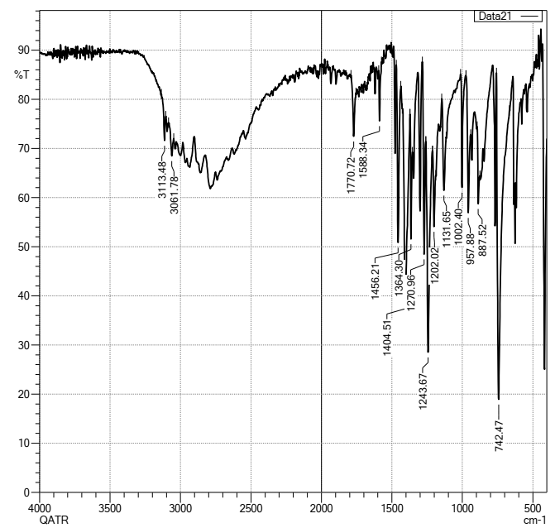
Figure 1: FTIR spectrum of the synthesized benzimidazole-based acrylic monomer
The stretching vibrations of carbonyl groups (-C=O-) were observed at 1770 cm⁻¹, absorption of azo groups (-N=N-) was recorded at 1456 cm⁻¹, and the stretching vibrations of double bonds (-C=C-) appeared at 1588 cm⁻¹. Additionally, the stretching vibrations of C–N and -N–C=O- bonds were observed at 1131 cm⁻¹ and 620 cm⁻¹, respectively. These data confirm the presence of key functional groups in the structure of the synthesized monomer.
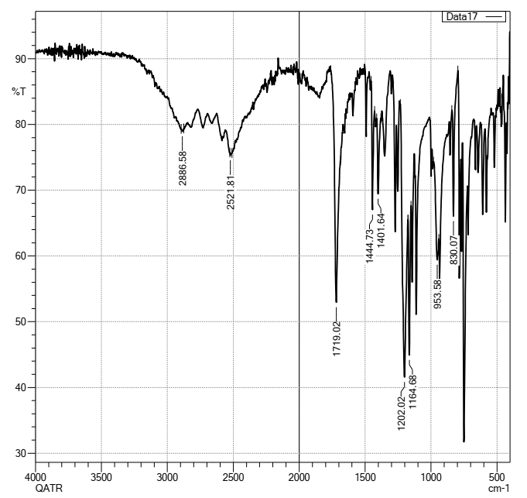
Figure 2: FTIR spectrum of the synthesized benzotriazole-based acrylic monomer

The FTIR spectrum of the synthesized BTAA monomer is shown in Figure 2. The absorption band at 1719 cm⁻¹ can be attributed to the stretching vibration of the carbonyl group of the acryloyl fragment. The bands observed at 1445 and 1402 cm⁻¹ are associated with C=N and C=C stretching vibrations of the benzotriazole ring. The absorption bands at 1202 and 1165 cm⁻¹ may be assigned to C–N stretching vibrations. The bands at 954 and 800 cm⁻¹ are characteristic of out-of-plane C–H bending vibrations of vinyl and aromatic fragments. These spectral features support the presence of the benzotriazole ring and the acrylic fragment in the structure of the synthesized monomer.
Thermal analysis of the synthesized benzotriazole-based acrylic monomer was carried out by simultaneous thermogravimetric and differential thermal analysis (TGA/DTA) in the temperature range of 23–600 °C, as shown in Figure 3.
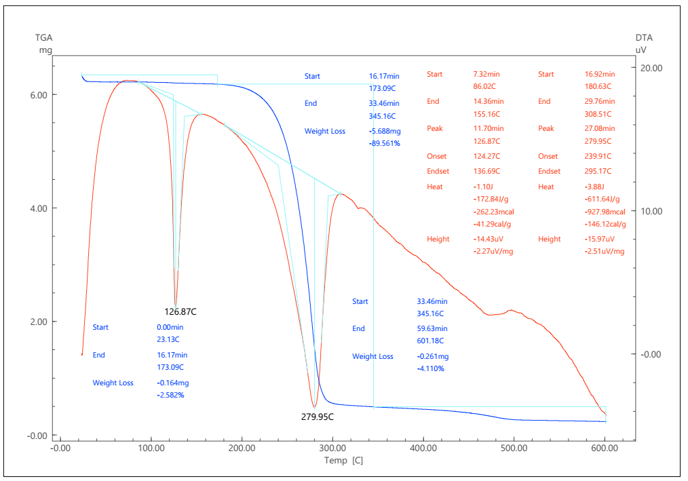
Figure 3: TGA/DTA curves of the synthesized benzotriazole-based acrylic monomer

The TGA curve indicates a three-stage mass-loss process. The first stage, observed in the range of 23.13–173.09 °C, was accompanied by a small mass loss of 2.582 %. The thermal event at 126.87 °C on the DTA curve may be attributed to the removal of physically adsorbed moisture and residual solvent remaining after synthesis and purification. The second stage occurred in the range of 173.09–345.16 °C and corresponded to the main decomposition process of the monomer, with a mass loss of 89.561 %. The pronounced DTA peak at 279.95 °C indicates intensive thermal degradation of the benzotriazole-containing acrylic structure. The third stage was observed between 345.16 and 601.18 °C and was associated with further degradation and carbonization of intermediate decomposition products, with an additional mass loss of 4.110 %. At 600 °C, the residual mass was approximately 3.75 %, indicating the formation of a small amount of thermally stable carbonaceous residue. Overall, the synthesized monomer showed relative thermal stability up to the onset of intensive decomposition, while the main degradation process occurred near 280–300 °C.
Microscopic analysis of the synthesized monomers was carried out to evaluate their crystal morphology. Figure 4 shows microphotographs of the benzimidazole-based and benzotriazole-based acrylic monomers at different magnifications. The images indicate that the obtained products consist mainly of transparent crystalline particles with rod-like and prismatic shapes. The crystals show a moderate tendency to aggregate, which may be associated with intermolecular interactions and partial adhesion between particles during crystallisation. These observations confirm the crystalline nature of the synthesized monomers.
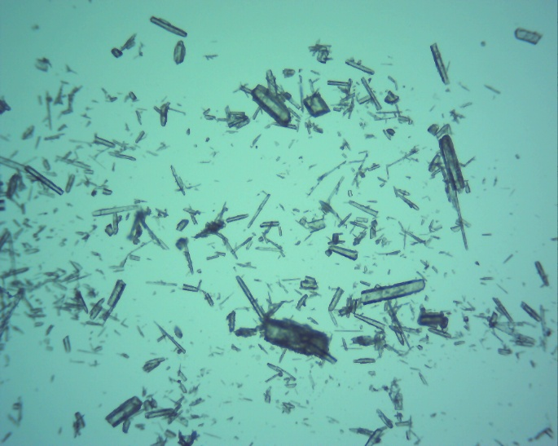 | 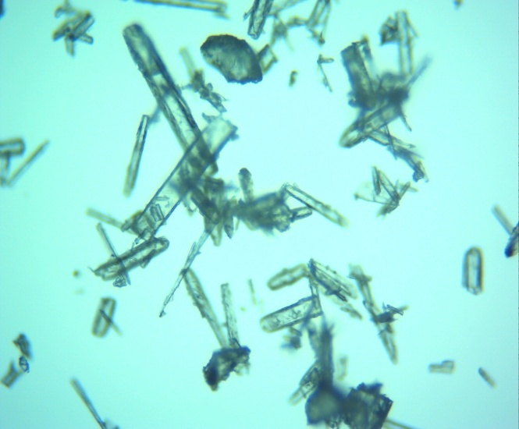 | (1)
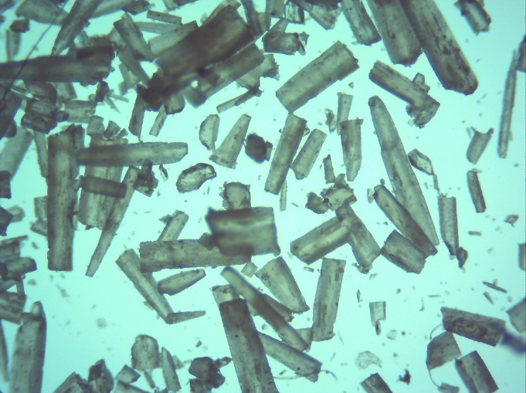  а) | 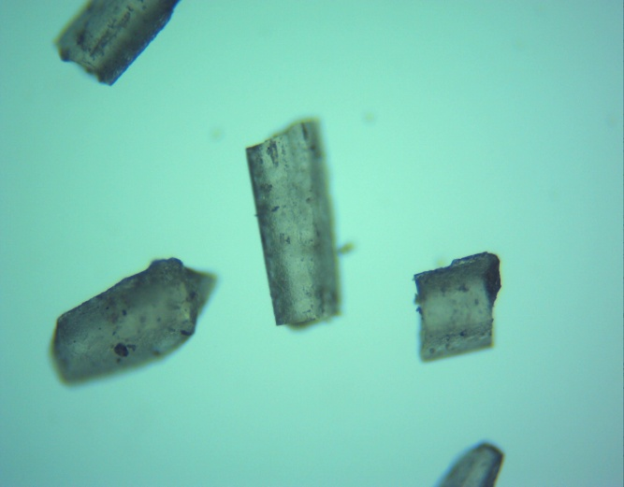  (b) | (2)
Figure 4: Microphotographs of the synthesized acrylic monomers based on benzimidazole and benzotriazole at different magnifications
  - CONCLUSIONS
In this study, new nitrogen-containing acrylic monomers based on benzimidazole and benzotriazole were synthesized and characterised. The optimal synthesis conditions were established by varying the reaction temperature, reaction time and molar ratio of the starting reagents. For the benzotriazole-based monomer, the optimal conditions were a molar ratio of 1:1, a temperature of 80 °C and a reaction time of 5 h, giving a yield of about 80 %. The structure of the synthesized monomers was supported by FTIR and ¹H NMR spectroscopy, while HPLC analysis indicated high chromatographic purity of the products. Thermal analysis showed that the synthesized monomers undergo multistage decomposition. The initial low-temperature mass loss was attributed to the removal of physically adsorbed moisture and residual solvent. The main decomposition stage occurred at higher temperatures and was associated with degradation of the heterocyclic acrylic structure. Microscopic analysis confirmed the formation of crystalline particles with rod-like and prismatic morphology. The obtained results indicate that the synthesized monomers are promising functional compounds for the development of polymer coatings with anticorrosion properties.
  - REFERENCES
Dandge, A.V., Manikpuriya, S. and Sanap, G. (2023) ‘Benzotriazole derivatives and its pharmacological activity’, International Journal in Pharmaceutical Sciences, 1(12), pp. 948–957. doi: 10.5281/zenodo.10443937.
Datta, A., Asnani, A., Mohurle, S., Kumar, P., Bais, A. and Tale, R. (2020) ‘Review on synthetic study of benzotriazole’, GSC Biological and Pharmaceutical Sciences, 11(02), pp. 215–225. doi: 10.30574/gscbps.2020.11.2.0137.
Duque-Alvarez, A.E., Lopez-Sesenes, R., Contreras-Valenzuela, M.R., Martinez-Oropeza, A., Vera-Dimas, J.G. and Zheludkevich, M. (2017) ‘Synergistic inhibition effect of rare earth in the corrosion of the AA2024-T3 and CFRP in galvanic couple’, Chemical Engineering Transactions, 57, pp. 1645–1650. doi: 10.3303/CET1757275.
Gong, Y., Wang, Z., Gao, F., Zhang, S. and Li, H. (2015) ‘Synthesis of new benzotriazole derivatives containing carbon chains as corrosion inhibitors for copper in sodium chloride solution’, Industrial & Engineering Chemistry Research, 54(49), pp. 12242–12253. doi: 10.1021/acs.iecr.5b02988.
Han, D.C., Kim, H. and Kwak, G. (2023) ‘Benzotriazole-containing fluorinated acrylic polymer coatings with high thermal stability, low surface energy, high visible-light transparency, and UV-blocking performance’, Polymer Bulletin, 80, pp. 5641–5654. doi: 10.1007/s00289-022-04340-w.
Khayyat, A.N., Mohamed, K.O., Malebari, A.M. and El-Malah, A. (2021) ‘Substituted imidazole-thione linked derivatives’, Molecules, 26(19), pp. 5983. doi: 10.3390/molecules26195983.
Kuksenok, V.Yu. and Shtrykova, V.V. (2023) Laboratory practical training in organic chemistry. Tomsk: Tomsk Polytechnic University.
Mariano, G., Valeria, P. and Miriam, M.A. (2023) ‘The synthesis and characterization of acrylic polymer with 1,2,3-benzotriazole pendant groups’, Polymer Science Peer Review Journal, 4(5), Article PSPRJ.000600. doi: 10.31031/PSPRJ.2023.04.000600
Selezneva, E.S., Valieva, E.A., Tengaev, E.I. and Belousova, Z.P. (2012) ‘The role of xenobiotic structure in the development of a biological response: the example of benzotriazole derivatives’, Bulletin of Samara State University – Natural Science Series, 3(1), p. 219.
Shah, J.J. and Mohanraj, K. (2014) ‘Comparison of conventional and microwave-assisted synthesis of benzotriazole derivatives’, Indian Journal of Pharmaceutical Sciences, 76(1), pp. 46–53.
Tadjiyeva, S.A., Maksumova, O.S. and Tadjiyeva, G.A. (2020) ‘Synthesis of N,N-diallylbenzotriazol bromide’, Journal of Critical Reviews, 7(6), pp. 725–728.
Tadjiyeva, S.A. and Maksumova, A.S. (2020) ‘Synthesis of monomeric quaternary ammonium salts’, Universum: Chemistry and Biology, 7(73).
Tajudeen, J., Adebayo, O., Hamisu, I., James, H. and David, A. (2022) ‘Biological evaluation and docking study of synthesized derivatives of benzotriazole and benzimidazole as antibacterial agents’, Chemistry Africa, 5, pp. 509–523.

